**Automate the Web Application**

**Project objective:**

Use the website link given to you and automate different functionalities for the same. Create a new project and include all the dependencies in the class path. Create a Java class that will contain your automation and test scripts. Run the project using TestNG

**You must use the following:**

● Eclipse as the IDE  
● TestNG  
● Selenium WebDriver

**Following requirements should be met:**

● Show a registration form, login, search bar, and add-to-cart automation  
● Handle invalid logins and show appropriate error messages in the console  
● Fetch the test reports over HTML or Excel  
● Document the step-by-step process involved in completing this task

**Screenshots :-** 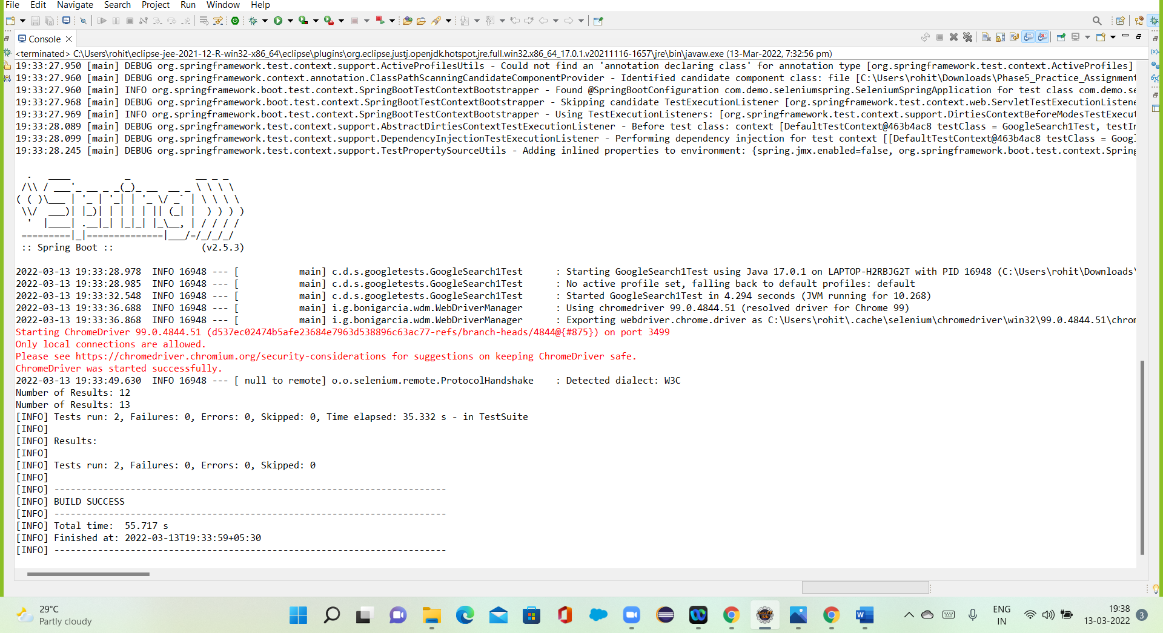

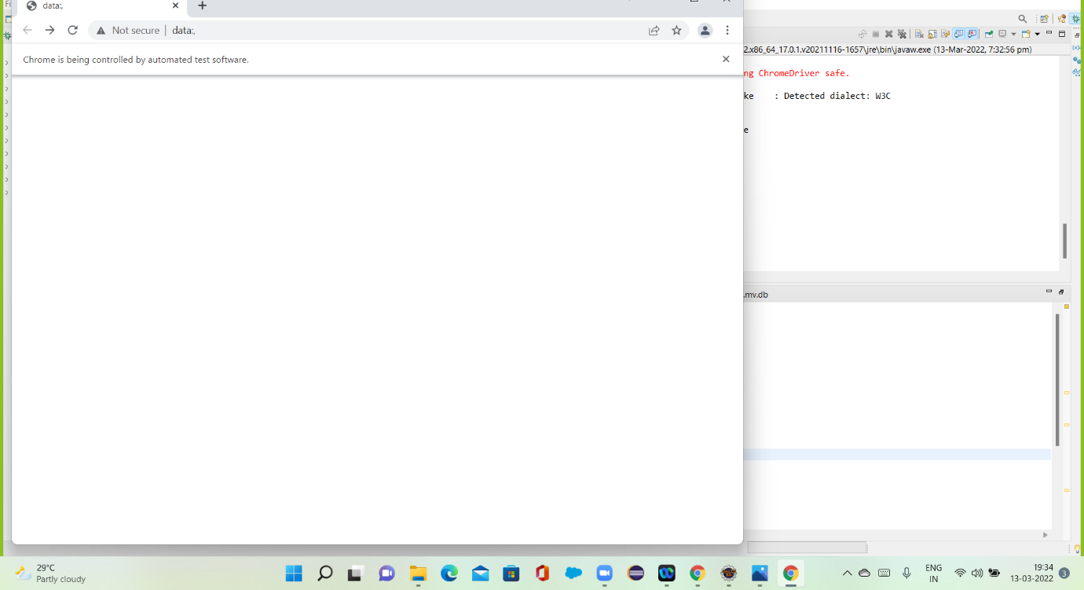

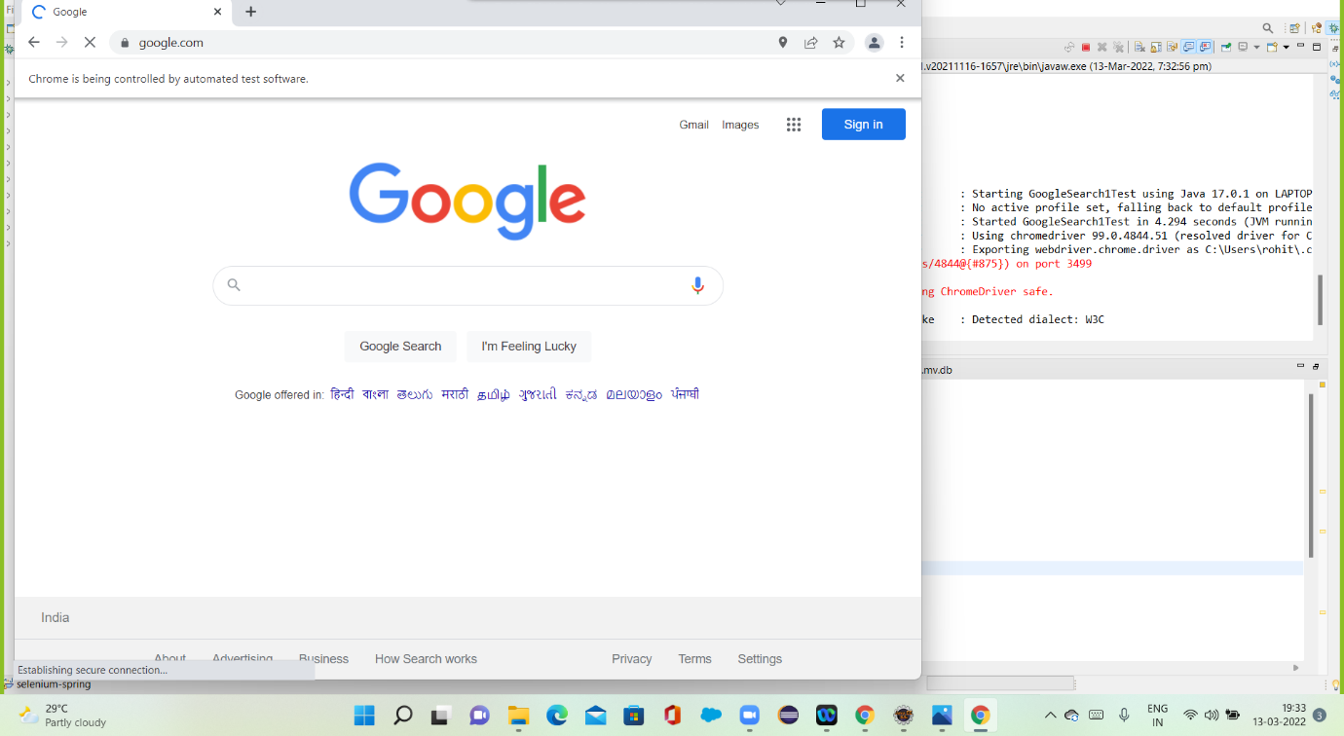

## **Pushing the code to GitHub repository:**

* Open your command prompt and navigate to the folder where you have created your files.

**cd <folder path>**

* Initialize repository using the following command:

**git init**

* Add all the files to your git repository using the following command:

**git add .**

* Commit the changes using the following command:

**git commit . -m <commit message>**

* Push the files to the folder you initially created using the following command:

**git push -u origin master**